**Exp No.** 15 **Name:** PONNURI ANIRUDDHA

**Date**: 14/11/2022 **Reg No:** RA2112704010015

**File organization schemes for single level and two-level directory**

**Aim: --**

To implement File organization schemes for single level and two-level directory

**Procedure: --**

A File system contains thousands and millions of files, owned by several users. The directory structure organizes these files by keeping entries of all the related files. The file entries have information like file name, type, location, the mode in which the file can be accessed by other users in the system. Directory structure provides both the above-discussed features. A directory always has information about the group of related files. Whenever a user or a process request for a file, the file system search for the file’s entry in the directory and when the match is found, it obtains the file’s location from there.

**Types of Directory Structures**

1. **Single-level directory structure**

Single level directory structure has only one directory which is called the root directory. The users are not allowed to create subdirectories under the root directory. All the files created by the several users are present in the root directory only.

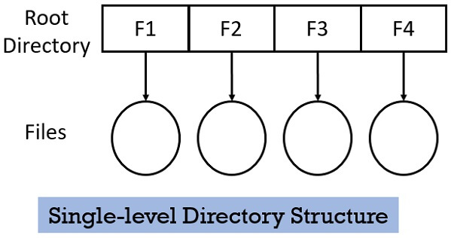

There is one drawback of Single-level directory structure, a user cannot use the same file name used by another user in the system. Even if the file with the same name is created the old file will get destroyed first and replaced by the new file having the same name.

**2. Two-level directory structure**

In Two-level directory structure, the users create directory directly inside the root directory. But once a user creates such directory, further he cannot create any subdirectory inside that directory. Observe the figure below, 4 users have created their separate directory inside the root directory. But further, no subdirectory is created by the users.

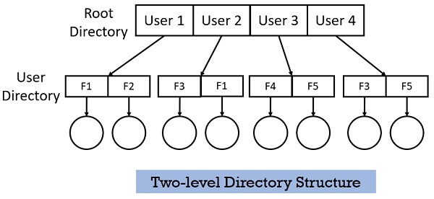

This two-level structure allows each user to keep their files separately inside their own directory. This structure allows to use the same name for the files but under different user directories.

**CODE (Single-level directory structure): --**

*#include<stdio.h>*

*#include<stdlib.h>*

*#include<string.h>*

*void main()*

*{*

*int nf=0,i=0,j=0,ch;*

*char mdname[10],fname[10][10],name[10];*

*printf("Enter the directory name:");*

*scanf("%s",mdname);*

*printf("Enter the number of files:");*

*scanf("%d",&nf);*

*do*

*{*

*printf("Enter file name to be created:");*

*scanf("%s",name);*

*for(i=0;i<nf;i++)*

*{*

*if(!strcmp(name,fname[i]))*

*break;*

*}*

*if(i==nf)*

*{*

*strcpy(fname[j++],name);*

*nf++;*

*}*

*else*

*printf("There is already %s\n",name);*

*printf("Do you want to enter another file(yes - 1 or no - 0):");*

*scanf("%d",&ch);*

*}*

*while(ch==1);*

*printf("Directory name is:%s\n",mdname);*

*printf("Files names are:");*

*for(i=0;i<j;i++)*

*printf("\n%s",fname[i]);*

*}*

**OUTPUT (Single-level directory structure): --**

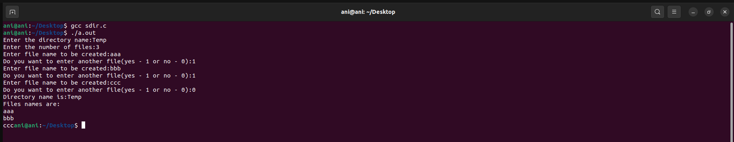

CODE: --

*#include<stdio.h>*

*#include<stdlib.h>*

*#include<string.h>*

*struct st*

*{*

*char dname[10];*

*char sdname[10][10];*

*char fname[10][10][10];*

*int ds,sds[10];*

*}dir[10];*

*void main()*

*{*

*int i,j,k,n;*

*printf("enter number of directories:");*

*scanf("%d",&n);*

*for(i=0;i<n;i++)*

*{*

*printf("enter directory %d names:",i+1);*

*scanf("%s",dir[i].dname);*

*printf("enter size of directories:");*

*scanf("%d",&dir[i].ds);*

*for(j=0;j<dir[i].ds;j++)*

*{*

*printf("enter subdirectory name and size:");*

*scanf("%s",dir[i].sdname[j]);*

*scanf("%d",&dir[i].sds[j]);*

*for(k=0;k<dir[i].sds[j];k++)*

*{*

*printf("enter file name:");*

*scanf("%s",dir[i].fname[j][k]);*

*}*

*}*

*}*

*printf("\ndirname\t\tsize\tsubdirname\tsize\tfiles");*

*printf("\n********************\n");*

*for(i=0;i<n;i++)*

*{*

*printf("%s\t\t%d",dir[i].dname,dir[i].ds);*

*for(j=0;j<dir[i].ds;j++)*

*{*

*printf("\t%s\t\t%d\t",dir[i].sdname[j],dir[i].sds[j]);*

*for(k=0;k<dir[i].sds[j];k++)*

*printf("%s\t",dir[i].fname[j][k]);*

*printf("\n\t\t");*

*}*

*printf("\n"); }*

*}*

**OUTPUT (Two-level directory structure): --**

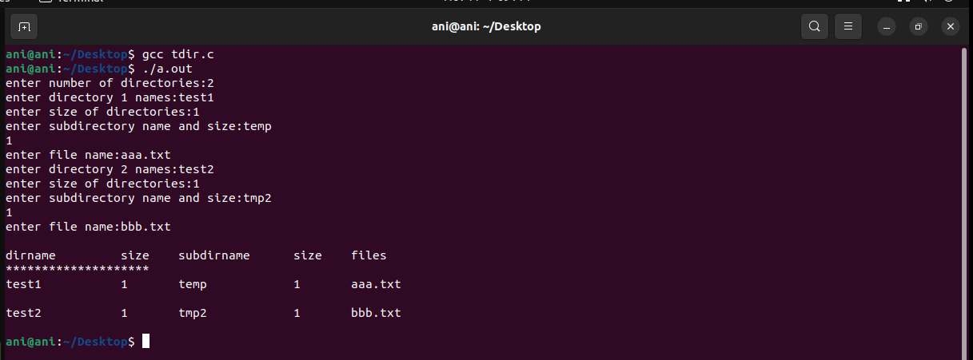

**RESULT: --**

Successfully implemented File organization schemes for single level and two level directory using c language.